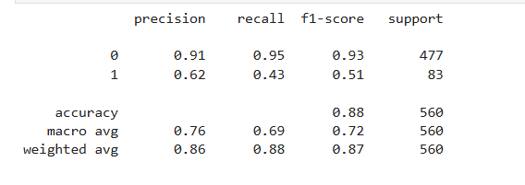
Receiver Operating Characteristic – Area Under the Curve
ROC-AUC is measuring how well this model can separate customers who will respond from those who won’t, across all possible decision thresholds.

strong model

MntWines – Amount spent on Wines
“I built a customer response prediction model using Logistic Regression, engineered behavioral and spending features, evaluated performance using ROC-AUC, and produced probability scores for campaign targeting.”

